**Assignment 4**

In Assignment 4, you will use concepts from the PowerPoint slides in Week 4.

Please make sure to put all answers into a single PDF or Word/RTF document. Do not submit as separate files please. In the document, include all steps as I have listed here. For each step, show your code/step as well as a screenshot of the results when you complete the action (if applicable). If a step does not indicate whether to complete in T-SQL code or using the GUI provided in SQL Server Management Studio, then either one is acceptable. However, if it does indicate which method to use, please use the method indicated.

In this assignment, students will backup and perform restore operations on the AdventureWorks2019 database.

* In Management Studio, verify in the properties of the database that AdventureWorks2019 uses the **full** recovery model. If it does not, change the database so that it does.

**Answer:** Expand the Database to Open AdventureWorks, to verify the database we highlight and then right click to get the properties then go to Options Tab and switch the recovery model from "Simple" to "Full".

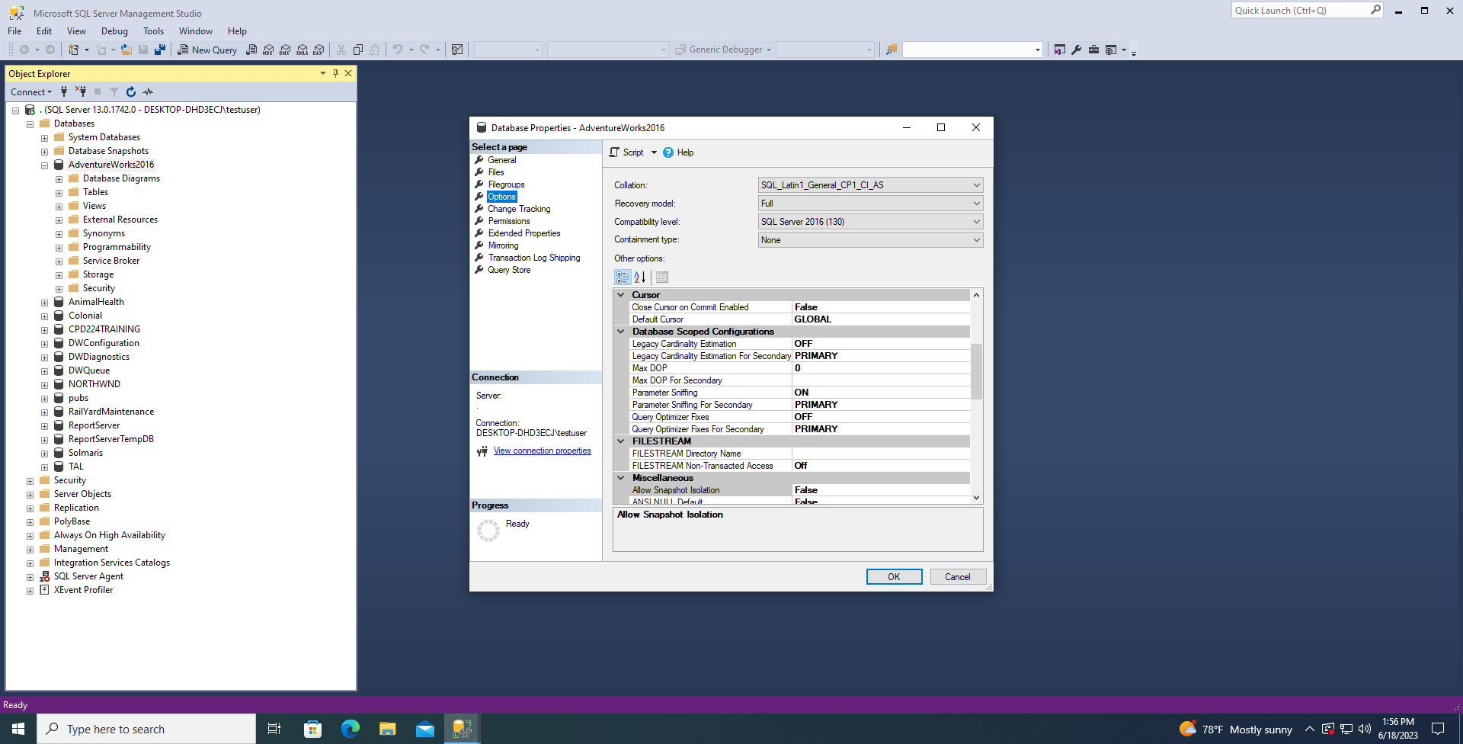

* Create a backup device named adv2019back that uses the C:\backup\adv2019back.bak file. Note that if the folder “backup” does not exist on C:, you will first need to create this folder on your computer (C:\backup).

**Answer:** Click to expand “Server Objects”, then right click on “Backup Devices” to create a device once that is done then you're going to right click on your back up to “Add a database” to your backup.

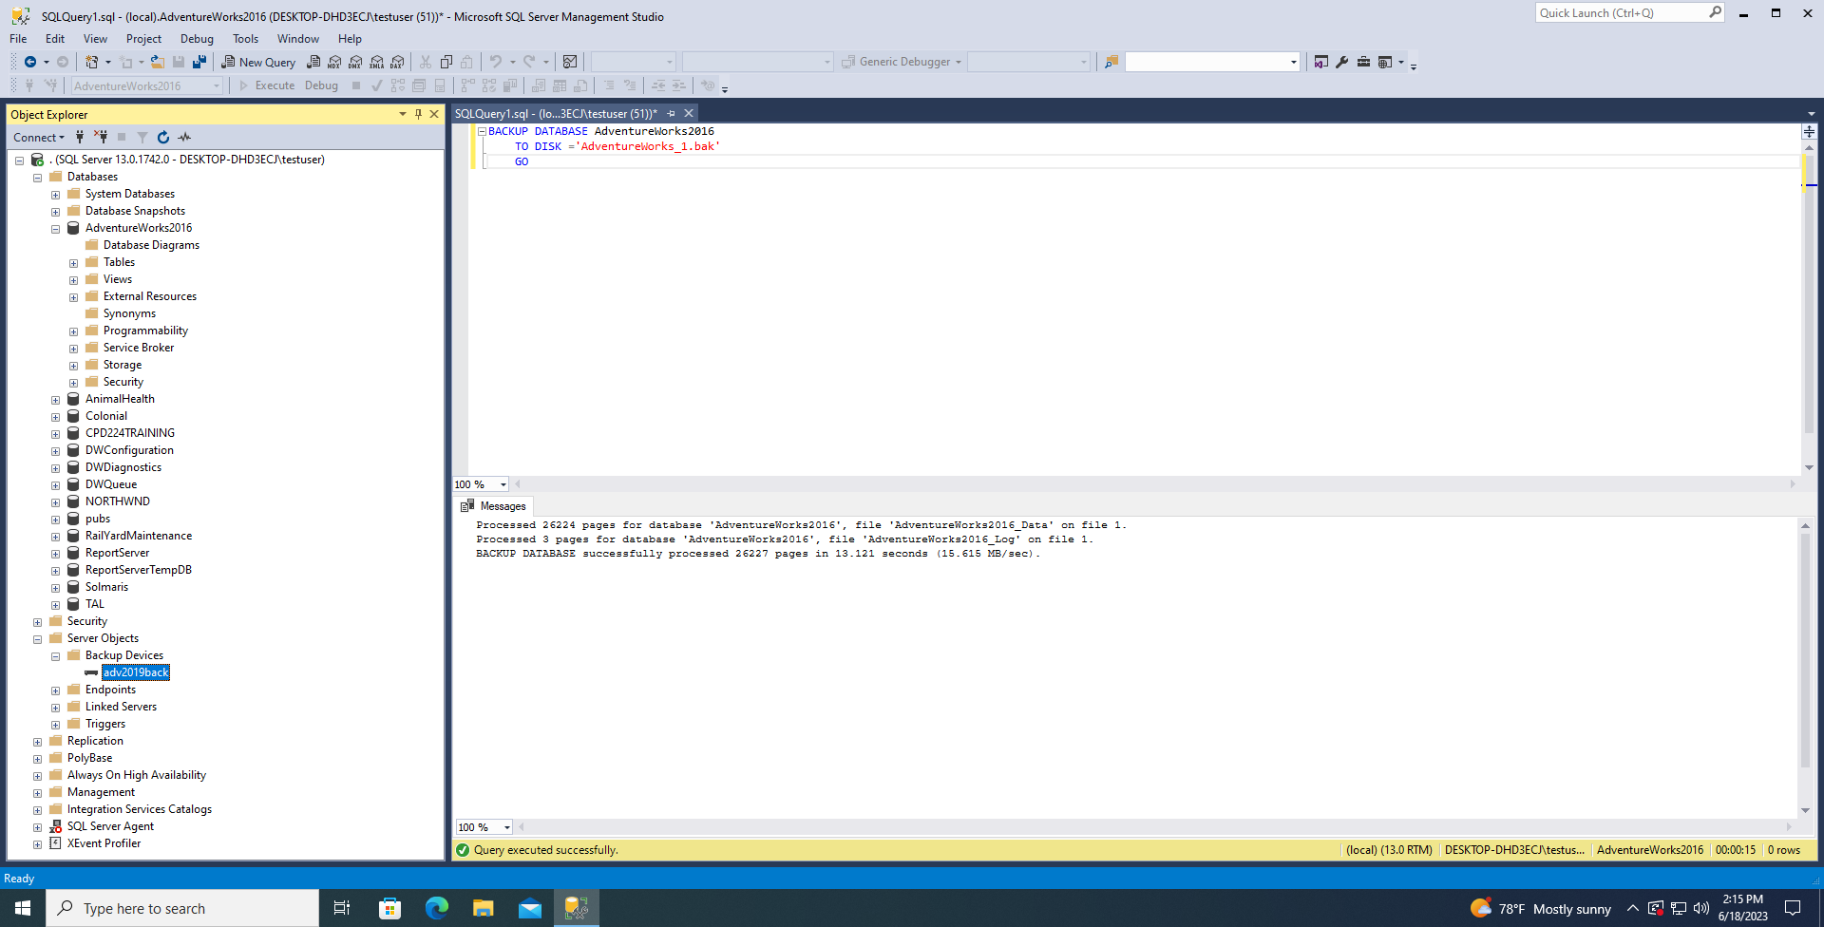

* Use T-SQL to create a full backup of the AdventureWorks2019 database by using the adv2019back backup device just created.

**Answer:**

BACKUP DATABASE AdventureWorks2016

TO DISK ='C:\Program Files\Microsoft SQL Server\MSSQL13.MSSQLSERVER\MSSQL\Backup\adv2019back.bak'

GO

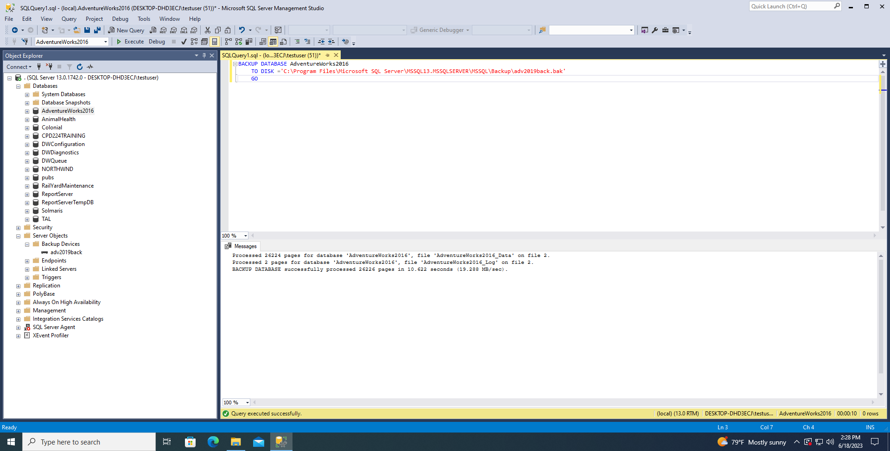

* Use T-SQL to perform a differential backup of the AdventureWorks2019 database to the same folder that you used in step #2. However this time don’t use the backup device itself, but specify the file path in the code. You may need to look back at your slides for how to do a BACKUP to a DISK location.

**Answer**: BACKUP DATABASE AdventureWorks2016

TO DISK ='C:\Program Files\Microsoft SQL Server\MSSQL13.MSSQLSERVER\MSSQL\Backup\adv2019back.dif'

WITH DIFFERENTIAL

GO

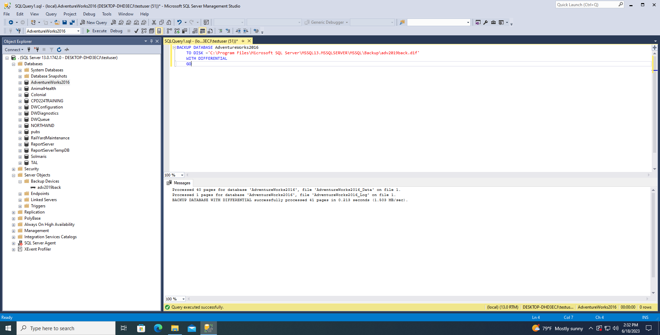

* Create a transaction log backup of the AdventureWorks2019 database by using the Back Up Database dialog box. Have this backup written to the same folder used in step #4. Make sure to use a unique name and the proper file extension for a log backup.

**Answer:** 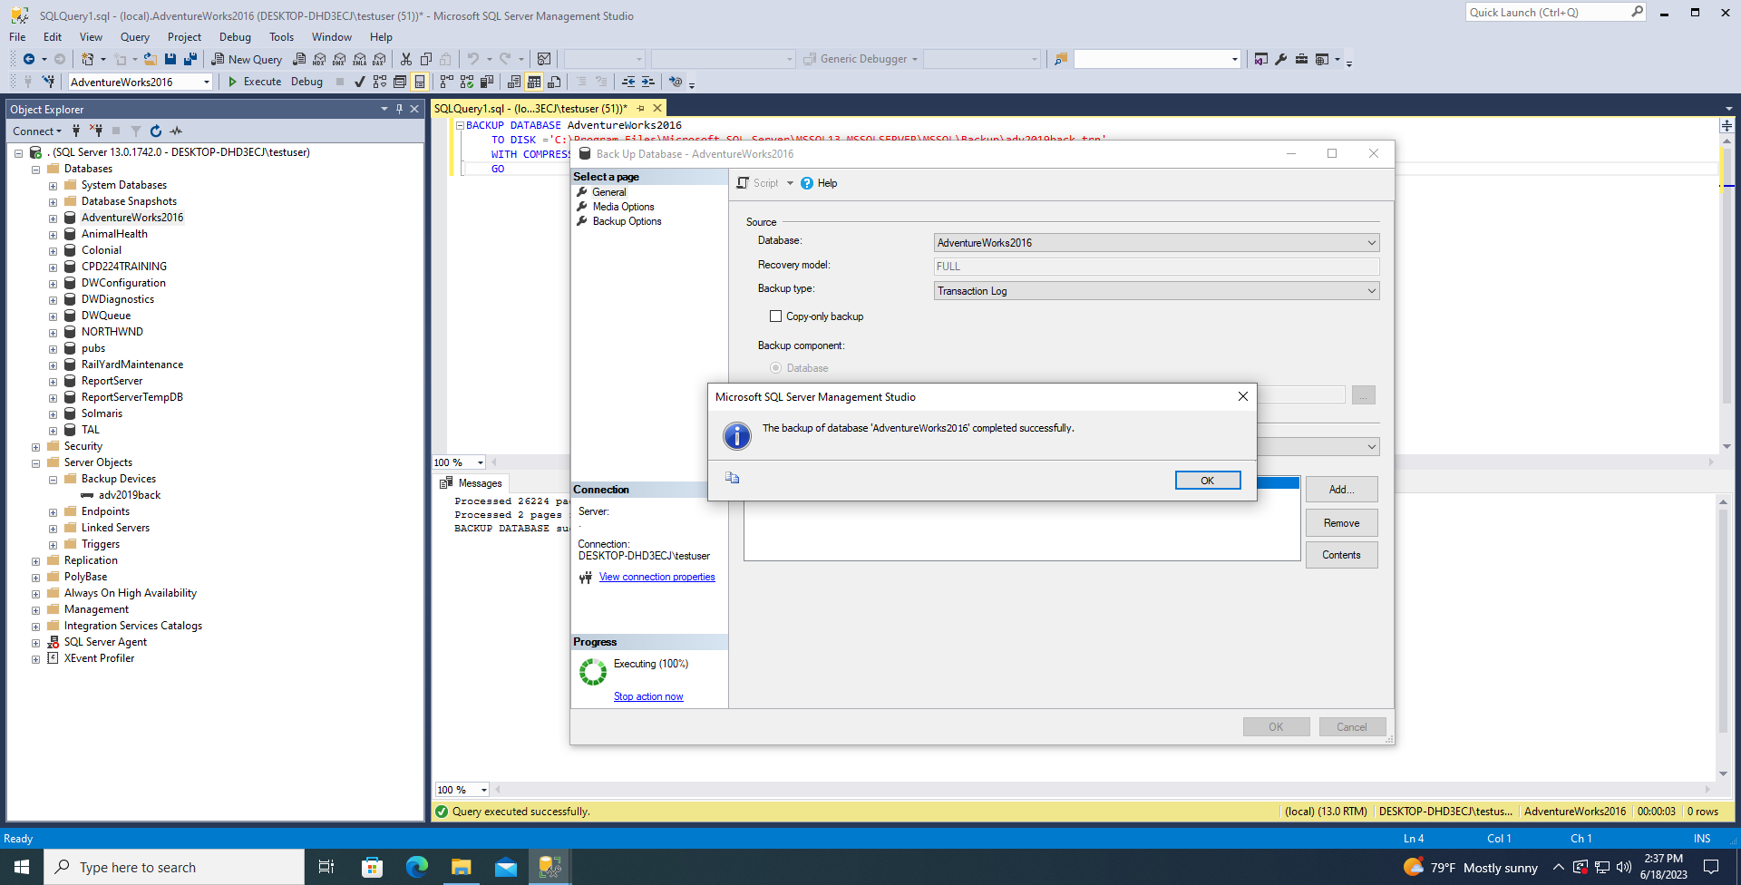

* Create a second transaction log backup of the AdventureWorks2019 database saved to the same folder, but this time use t-sql code. Make sure to use a different file name than that used in step #5.

**Answer:** BACKUP DATABASE AdventureWorks2016

TO DISK ='C:\Program Files\Microsoft SQL Server\MSSQL13.MSSQLSERVER\MSSQL\Backup\adv2019backlogs.trn'

WITH COMPRESSION, INIT,CHECKSUM,STOP_ON_ERROR

GO

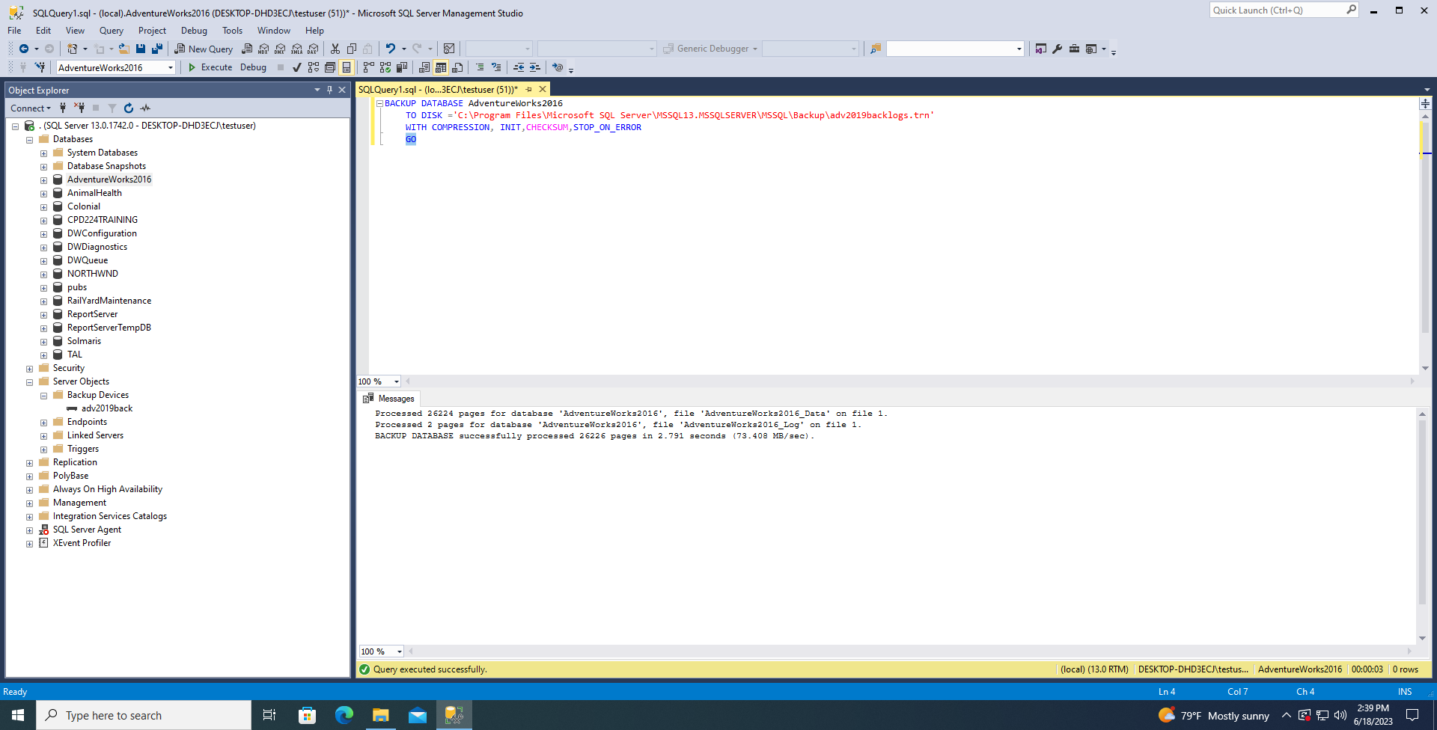

* Use a T-SQL statement to query the msdb.dbo.backupset table for information on the database name, backup finish time, backup size and backup type.

**Answer:** SELECT

backupset.database_name,

backupset.backup_finish_date,

backupset.backup_size,

backupset.type

from msdb.dbo.backupset

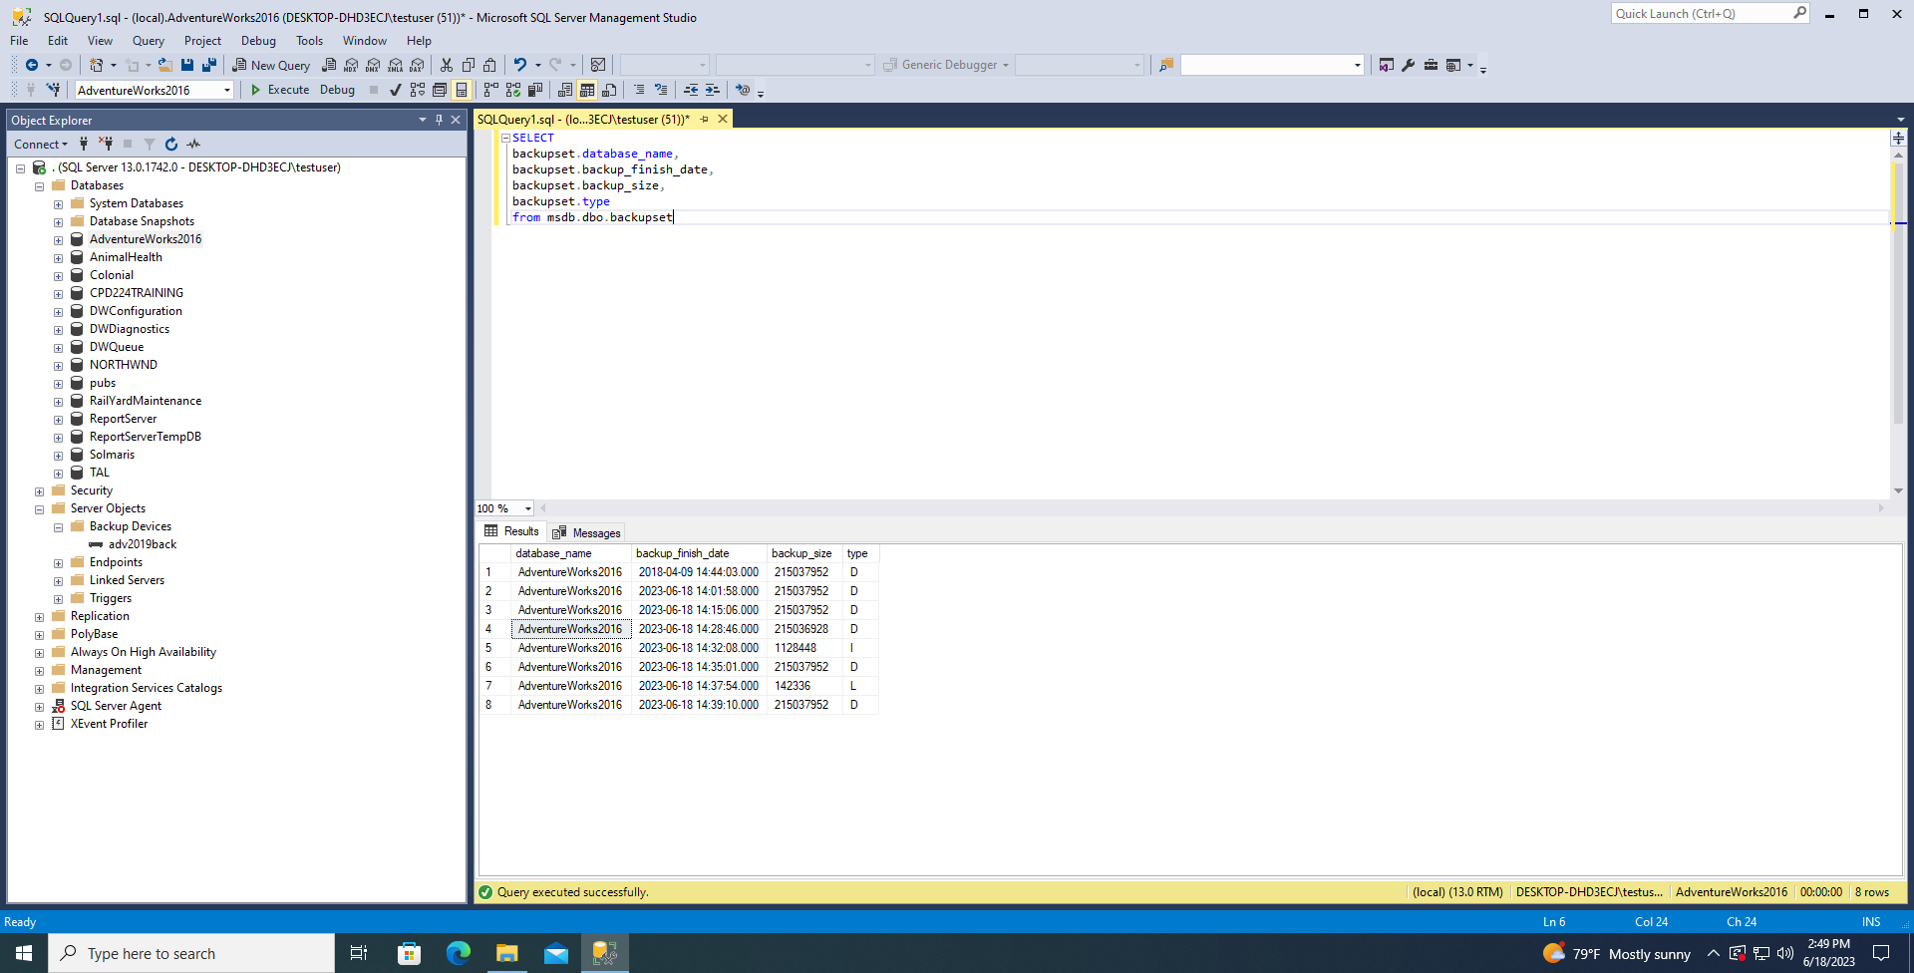

* All steps up to this point have been to back up our database using various methods and to view the backup information. Now we would like to simulate a database “disaster” on a small scale. Therefore, we will now deliberately delete one of the tables in our database. Drop the Sales.ShoppingCartItem table from the AdventureWorks2019 database using a T-SQL statement.

**Answer:**

DROP TABLE Sales.ShoppingCartItem

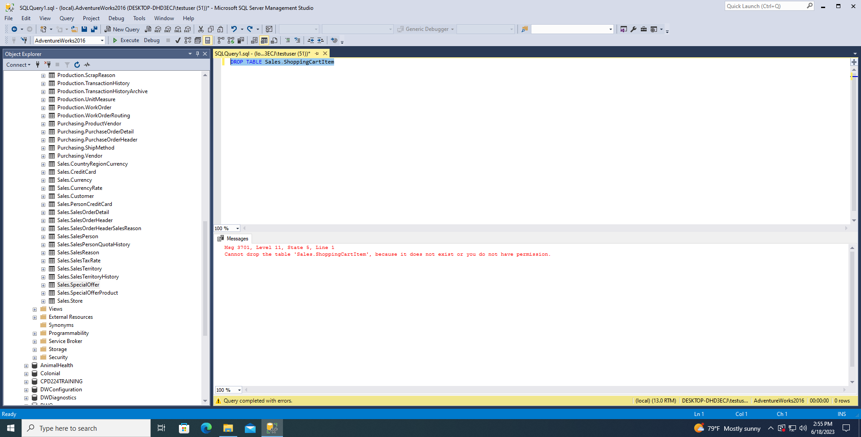

* Perform a full restore of the AdventureWorks2019 database using Management Studio’s GUI (Right click database>Tasks>Restore).

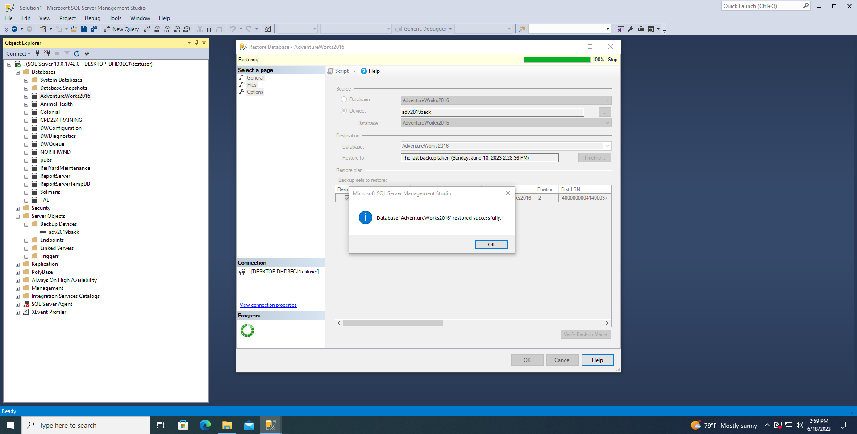

* Select all rows from Sales.ShoppingCartItem to show that the table has now been restored.

